DON BOSCO COLLEGE(CO-ED)
DEPARTMENT OF COMPUTER SCIENCE

DATE:05/03/2026
PROJECT TITLE: A CRM APPLICATION FOR THECHAISHOP&CO

COLLEGE CODE: 358
TEAM NAME: GROUP 11

Team Members:

Name | Reg.No
SWETHA PREETHI S | 35823U18053
VINNARASI SEBASTY A | 35823U18054
VISHAL G | 35823U18055
BOSHIYA JOSPIN MARY A | 35821U18008

FACULTY NAME: Ms. POOVARASI

A CRM APPLICATION FOR THE CHAI Shop & Co
Project Documentation

1. ABSTRACT
Customer Relationship Management (CRM) plays a vital role in improving customer satisfaction and business efficiency. This project, “A CRM Application for TheChaiShop&Co,” focuses on developing a Salesforce-based CRM system to manage customer, employer, and enterprise data effectively. The application automates order processing, billing calculations, and customer communication, reducing manual effort and errors. It provides real-time reports and dashboards that help management analyze sales performance and make informed decisions. By replacing traditional manual record keeping with a centralized cloud-based solution, the system enhances data accuracy, operational efficiency, and overall customer engagement.

2. INTRODUCTION
2.1 Project Overview
The project titled “A CRM Application for The Chai Shop & Co” focuses on designing and implementing a Salesforce-based Customer Relationship Management (CRM) system to efficiently manage customer, employer, and enterprise data. The application automates sales calculations, organizes customer interactions, and provides insightful reports and dashboards to support business decisions.
The CRM system replaces manual record keeping with a centralized, cloud-based solution that improves accuracy, productivity, and customer engagement.

2.2 Purpose of the Project
The purpose of this project is to:
• Streamline customer and employer data management
• Automate order quantity and billing calculations
• Reduce manual errors in sales processing
• Enable real-time reporting and dashboards
• Improve customer engagement through automated email notifications

3. PROBLEM STATEMENT
TheChaiShop&Co currently relies on manual and semi-digital methods to manage customer records, sales orders, and billing details. This approach leads to incorrect calculations, data duplication, delayed reporting, and inefficient customer communication. Sales representatives face difficulties in handling orders accurately, managers struggle to monitor sales performance in real time, and customers do not receive timely updates or personalized offers. Therefore, there is a need for an automated, secure, and scalable CRM system that can streamline data management, automate billing processes, and provide real-time insights to improve business operations and customer satisfaction.

4. IDEATION PHASE
4.1 Problem Analysis
User | Trying to Do | Problem | Reason | Feeling
Sales  Representative | Manage orders & billing | Incorrect calculations | Manual process | Stressed
Store Manager | Monitor sales | Delayed reports | Data scattered | Confused
Customer | Receive offers | No timely updates | No automation | Undervalued

4.2 Empathy Map Canvas – Target Users
• Sales Representatives
• Managers
• System Administrators
Aspect | Description
Think & Feel | Need accurate data
Hear | Feedback from management
See | Multiple registers
Say & Do | Manual data entry
Pain | Errors and delays
Gain | Automation and reports

4.3 Brainstorming Considered Solutions
• Manual system
• Excel-based system
• Web-based CRM
• Salesforce-based CRM (Selected)
Reason for Selection:
Salesforce provides automation, scalability, security, and built-in analytics.

5. REQUIREMENT ANALYSIS PHASE
5.1 Customer Journey Map
- User Login
- Access CRM Application
- Enter Customer Data
- Generate Orders
- Automated Billing
- View Reports
- Decision Making
5.2 Solution Requirements
Functional Requirements
FR No | Description
FR-1 | User Login
FR-2 | Custom Object Creation
FR-3 | Data Entry
FR-4 | Automated Billing
FR-5 | Reports & Dashboards
FR-6 | Email Automation

Non-Functional Requirements
• Usability
• Security
• Reliability
• Performance
• Availability
• Scalability
5.3 Data Flow Diagram
User → Salesforce UI → Custom Objects → Validation Rules → Flows → Reports → Dashboards

6. PROJECT DESIGN PHASE
6.1 Problem–Solution Fit
The CRM system automates data handling, eliminates manual billing errors, and enables real-time reporting. It ensures faster operations and better customer interaction.
6.2 Proposed Solution
Key features implemented:
• Secure login and role-based access
• Customer, Employer, and Enterprise objects
• Record types and page layouts
• Formula fields for billing
• Validation rules
• Automated email alerts
• Reports and dashboards
6.3 Solution Architecture
Architecture Layers
- Presentation Layer – Salesforce Lightning UI
- Application Layer – Flows & Automation
- Data Layer – Custom Objects
- Analytics Layer – Reports & Dashboards

7. PROJECT PLANNING & SCHEDULING
7.1 Development Approach
• Agile-based development
• Sprint-wise implementation
• Continuous testing and validation

8. PROJECT DEVELOPMENT PHASE
8.1 Project Flow (Milestones)
- Developer Account Creation
- Object Creation
- Tabs
- Lightning App
- Global Picklists
- Fields & Relationships
- Page Layouts
- Record Types
- Validation Rules
- Email Templates
- Flows
- Reports & Dashboards

9. FUNCTIONAL & PERFORMANCE TESTING
During this phase, system functionality and performance were tested using the Salesforce Lightning interface.
9.1 Functional Testing
The following features were tested successfully:
• Creation of Employer, Customer, and Enterprise records
• Validation rules for Aadhaar, PAN, and phone number
• Record type selection and page layout switching
• Automated order quantity calculation
• Automated total bill calculation
• Birthday email flow execution
• Report and dashboard generation

Screenshot Placeholders (Attach here):
Screenshot 1: Employer Customer Account

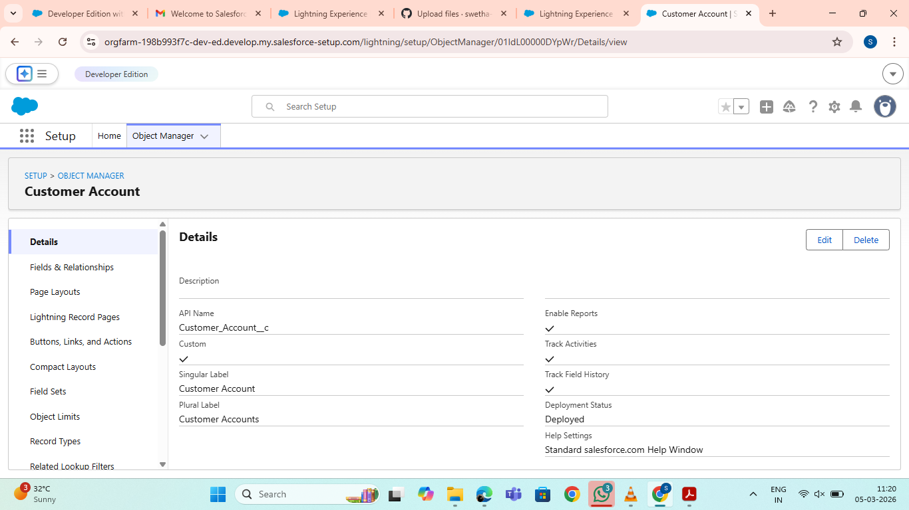

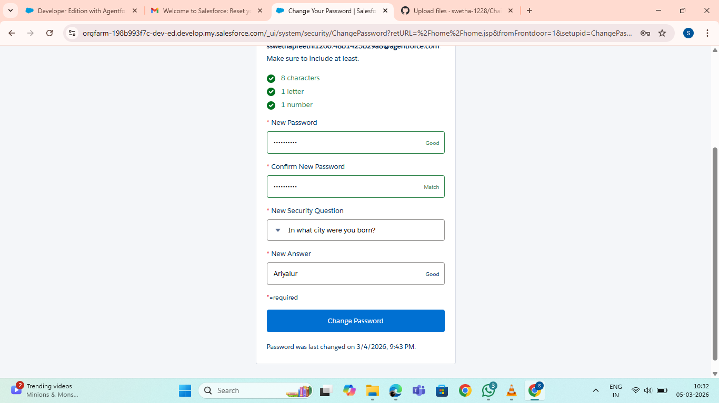
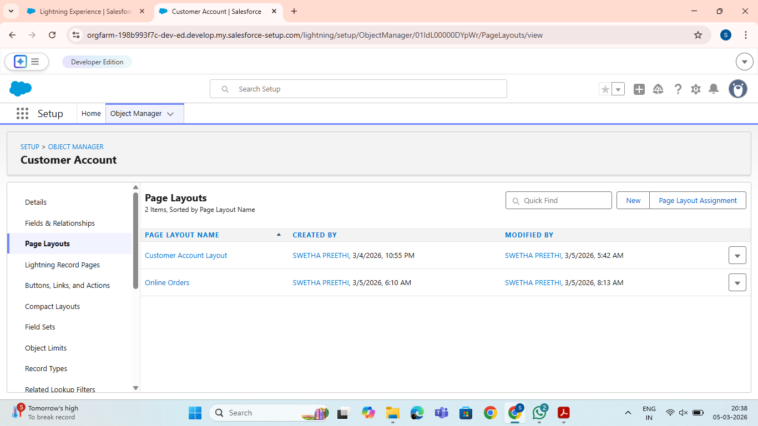

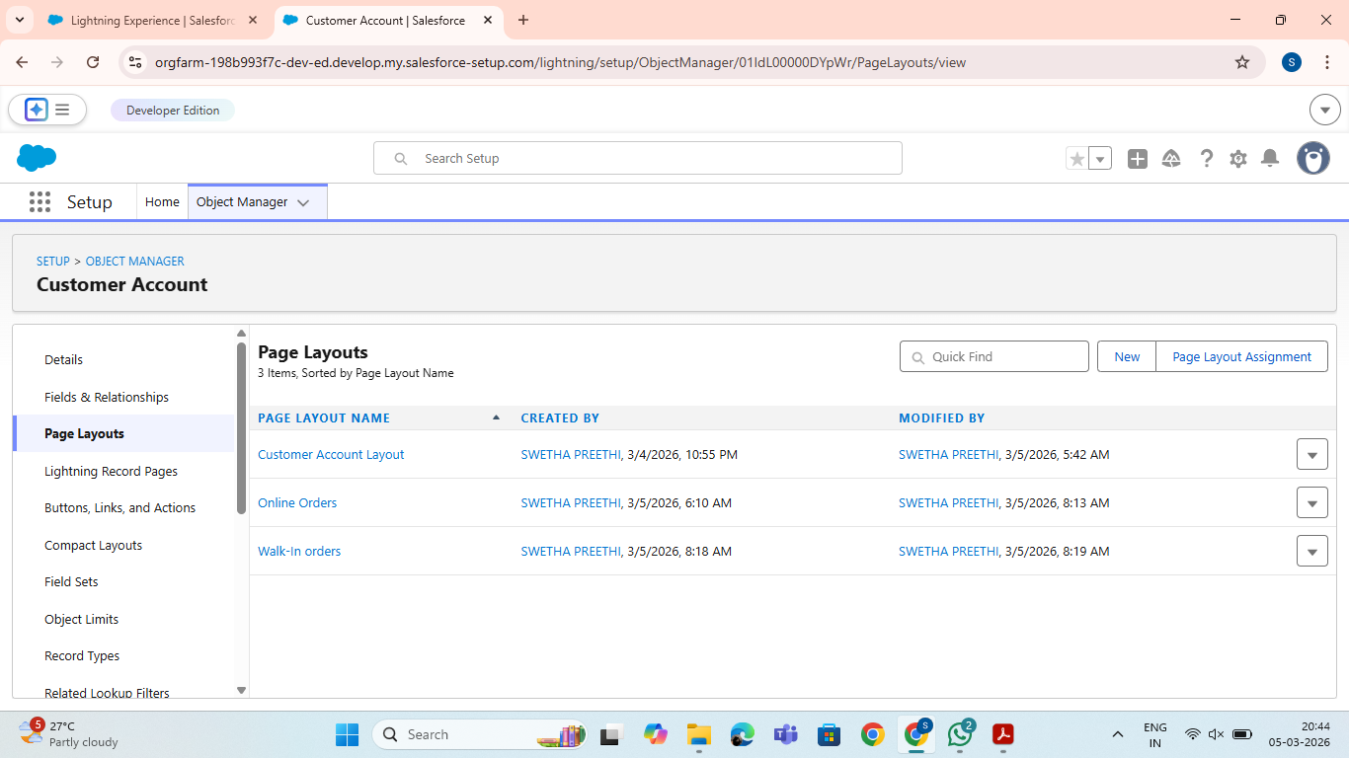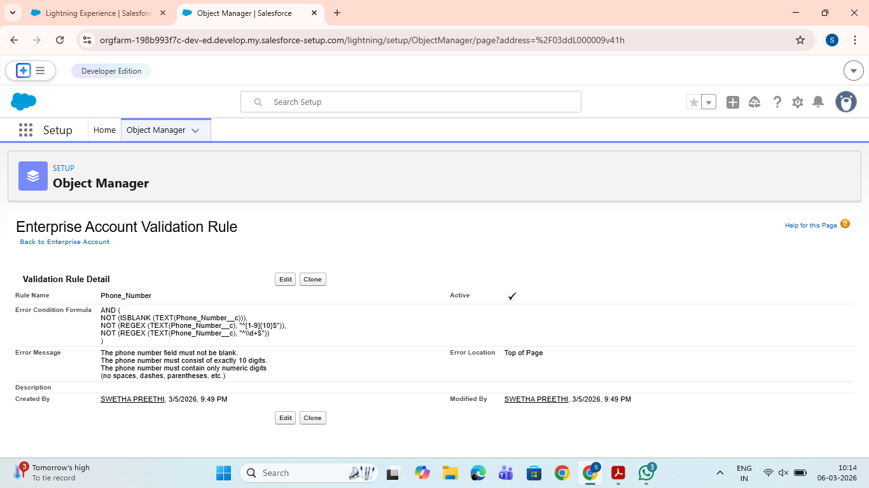

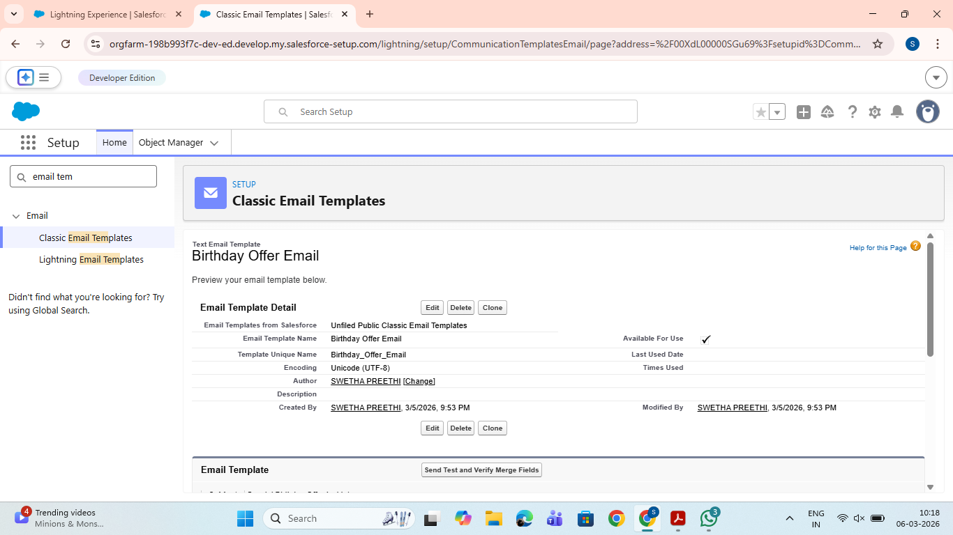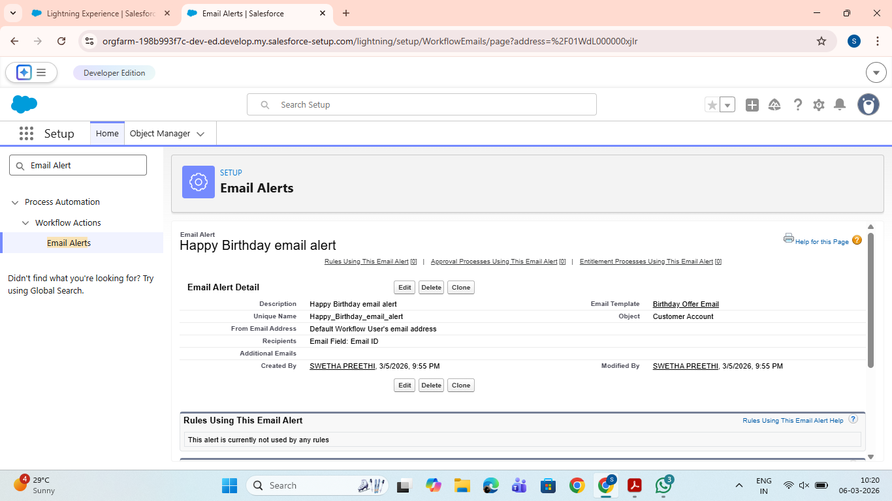

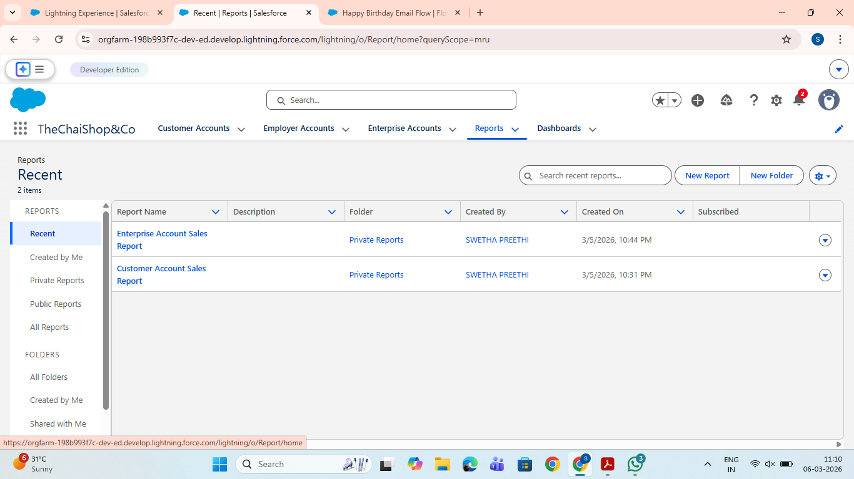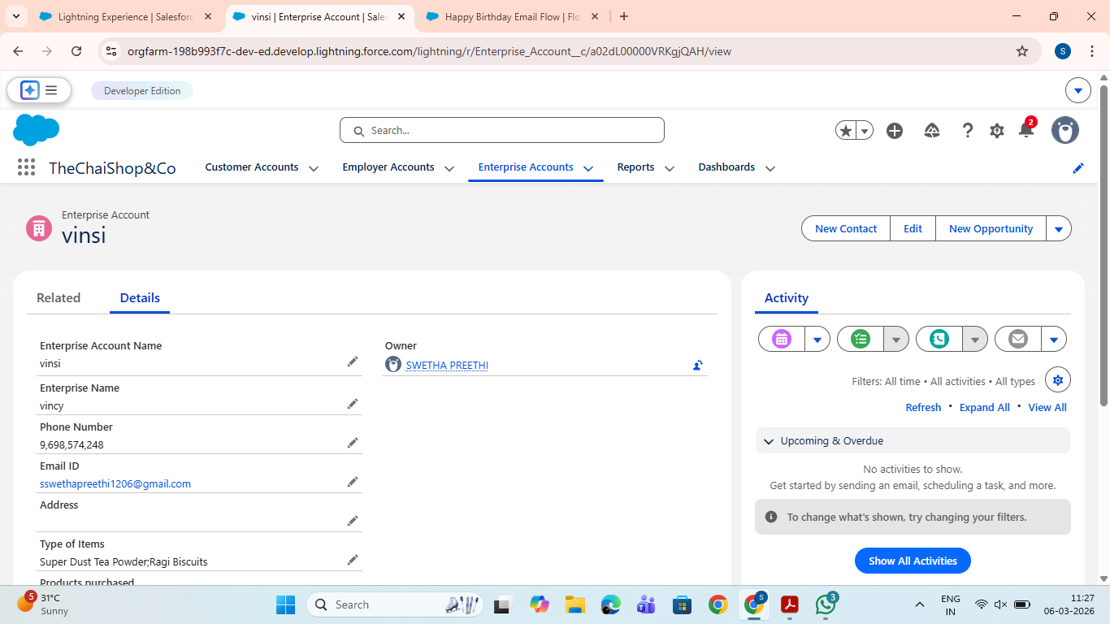

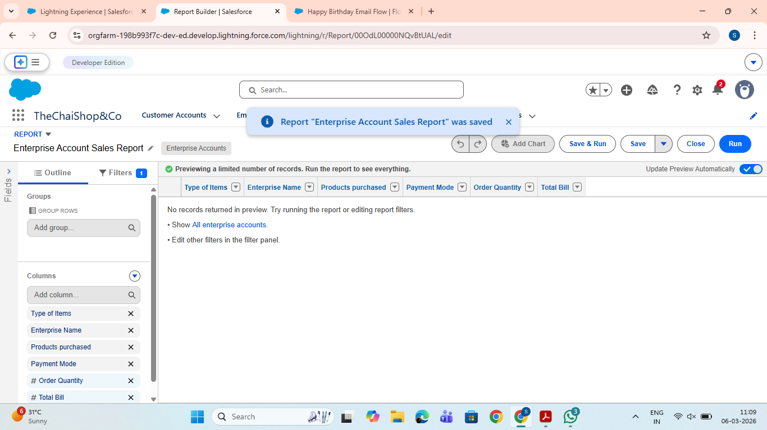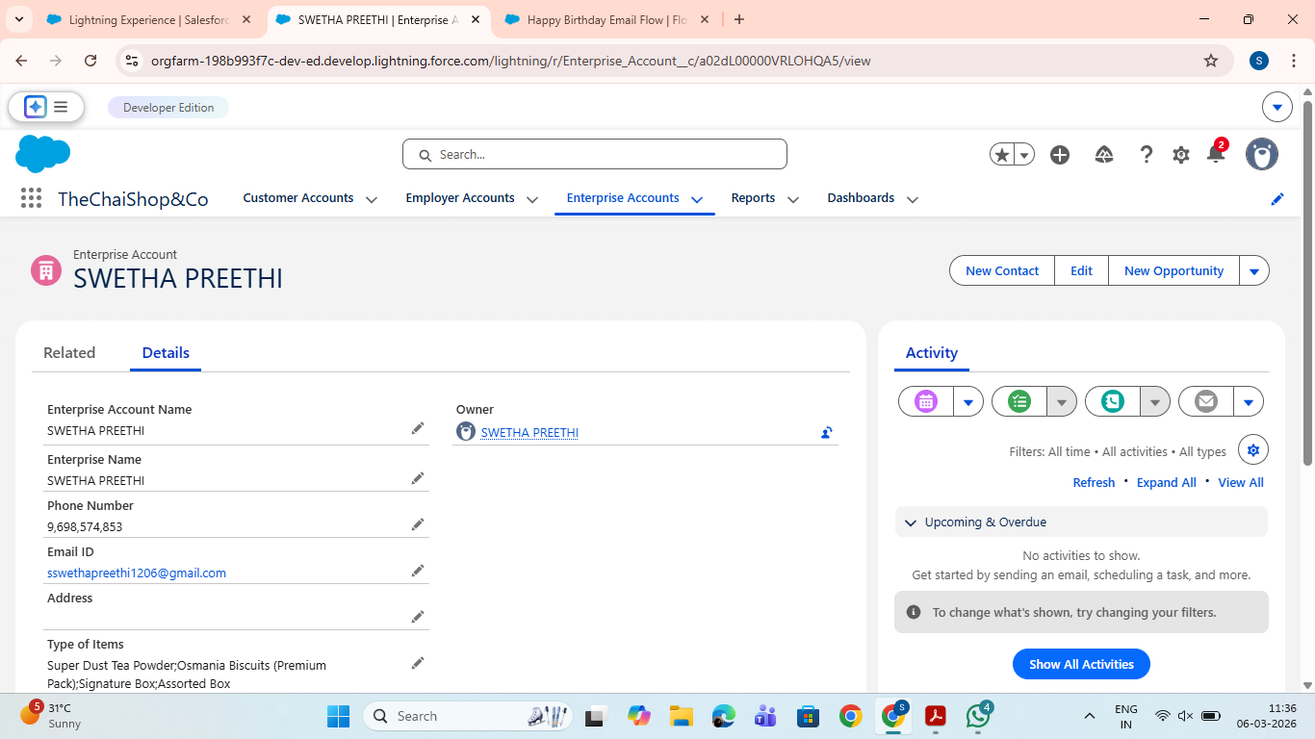

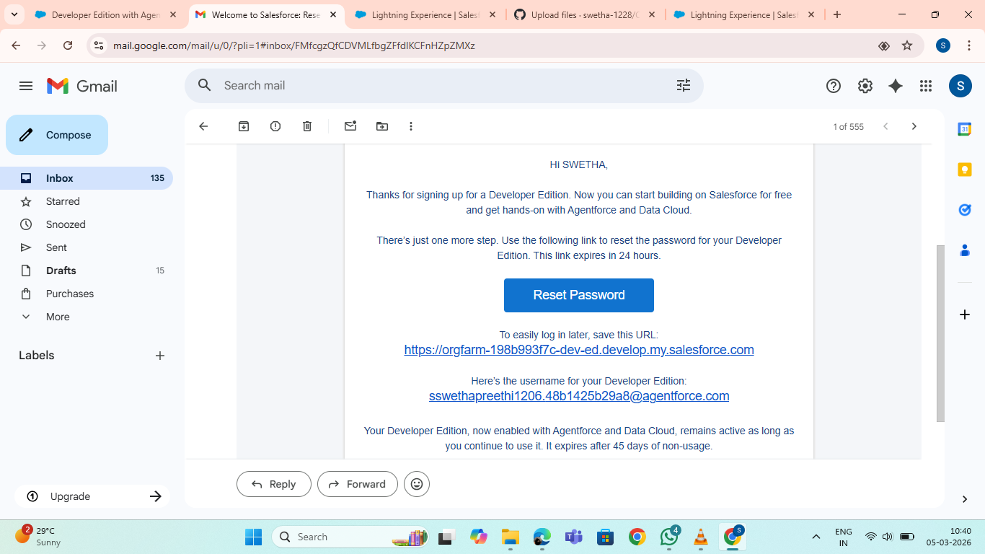

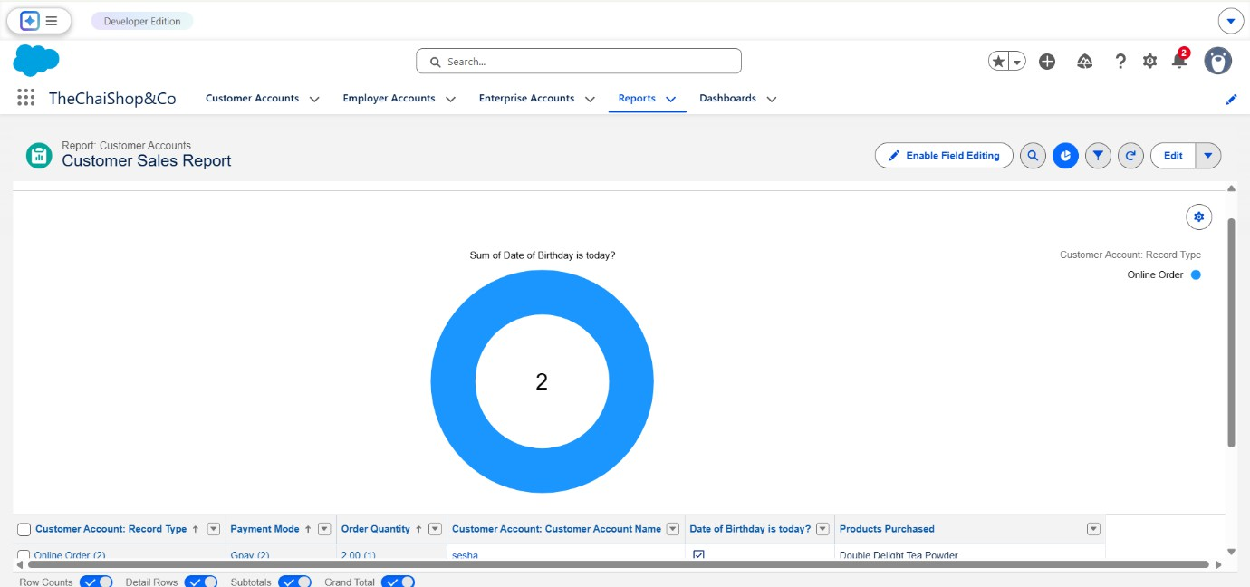
    - Screenshot 8: Customer Sales Repor

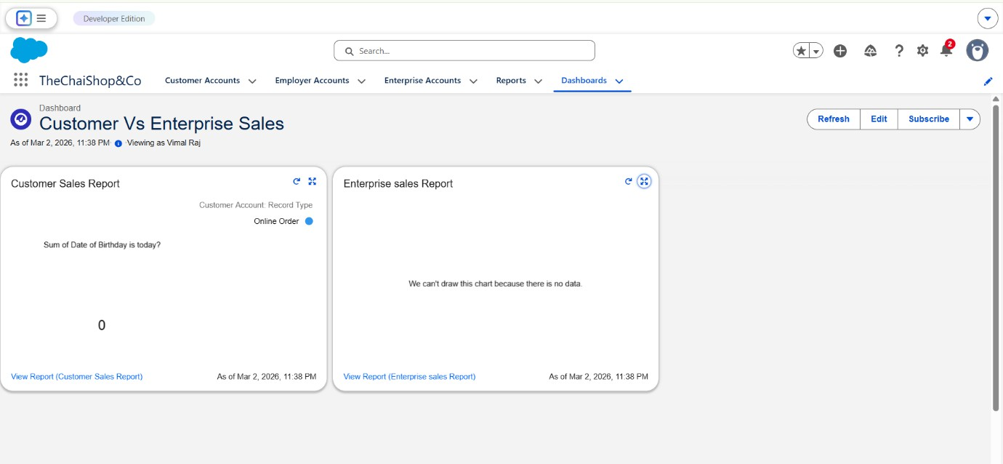
    - Screenshot 9: Dashboard View

9.2 Performance Testing
Performance testing verified:
• Fast page loading
• Quick report generation
• Smooth dashboard rendering
• Stable performance under multiple records
Screenshot Placeholder:
• Screenshot 10: Report Load Performance / Dashboard Performance
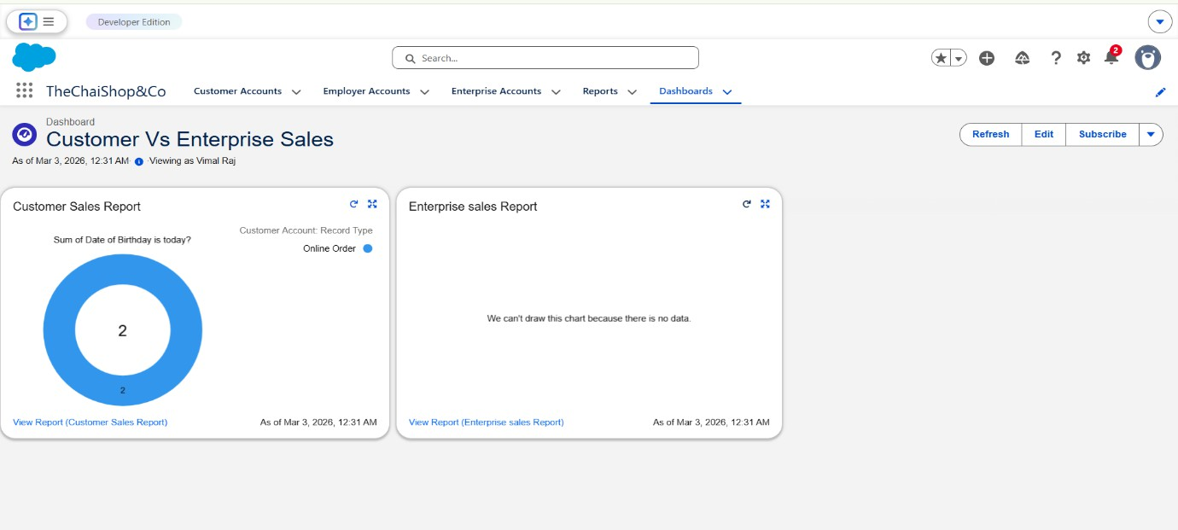
Dashboard Performance


Report Load Performance

10. ADVANTAGES & DISADVANTAGES
Advantages
• Centralized CRM system
• Automated billing
• Reduced errors
• Improved customer engagement
• Real-time analytics
Disadvantages
• Requires Salesforce license
• Internet dependency
• Limited offline access

11. SUMMARY OF THE PROJECT
The project “A CRM Application for TheChaiShop&Co” was developed using Salesforce to automate and streamline business processes related to customer management and sales operations. The system includes custom objects, record types, validation rules, formula fields, automated email notifications, and interactive reports and dashboards. It ensures accurate billing, reduces manual errors, and enables real-time monitoring of sales activities. The CRM application improves productivity, supports better decision-making, and enhances customer engagement. Overall, the project successfully demonstrates how a cloud-based CRM solution can modernize business operations and support future scalability.

12. CONCLUSION
The CRM Application for TheChaiShop&Co successfully enhances business operations by automating customer management, billing, and reporting. The system minimizes errors, saves time, and improves customer satisfaction through personalized communication.

13. FUTURE SCOPE
• Mobile CRM integration
• AI-based sales prediction
• SMS/WhatsApp alerts
• Inventory management
• Multi-branch support

14. APPENDIX
• Salesforce Configuration
• Custom Objects & Fields
• Flows and Email Templates
• Reports & Dashboard

